**EXERCISE -** 3

**LOGIC IMPLEMENTATION**

**Aim:** write a java program to perform arithmetic operations using scanner class.

**File name:** Scarthemtic.java

**Program:**

**import java.lang.*;**

**import java.util.*;**

**class Scarthemtic{**

**public static void main(String args[]){**

**int a,b;**

**Scanner s=new Scanner(System.in);**

**System.out.println("Enter a value:");**

**a = s.nextInt();**

**System.out.println("Enter b value:");**

**b = s.nextInt();**

**System.out.println("a + b is:"+(a+b));**

**System.out.println("a - b is:"+(a-b));**

**System.out.println("a * b is:"+(a*b));**

**System.out.println("a / b is:"+(a/b));**

**System.out.println("a % b is:"+(a%b));**

**}**

**}**

**Output:**

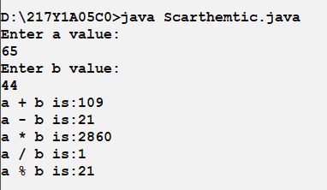

**Aim:** write a java program to perform Type casting.

**File name:** Typecast.java

**Program:**

**//HELLO**

**import java.lang.*;**

**import java.util.*;**

**class Typecast{**

**public static void main(String args[]){**

**int a=7;**

**float f = 3.876f;**

**char c1 = 's',c2 = 56, c3 = 260;**

**double d = 52.46516444231;**

**float f1 = a;**

**double d2 = f;**

**System.out.println("Float of 7 = " + f1);**

**System.out.println("Double of 3.876 = " + d2);**

**System.out.println("Int of 3.876 = " + (int)f);**

**System.out.println("Float of 52.46516444231 = " + (float)d);**

**System.out.println("Int of 52.46516444231 = " + (int)d);**

**System.out.println("Charecters are:"+c1+","+c2+","+c3);**

**}**

**}**

**Output:**

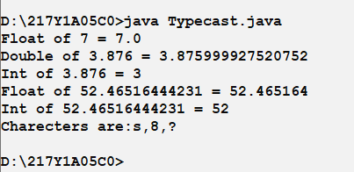**Aim:** write a java program find whether a number is armstrong number.

**File name:** Amstrong.java

**Program:**

**import java.lang.*;**

**import java.util.*;**

**class Amstrong{**

**public static void main(String args[]){**

**int n,sum=0,m;**

**Scanner s=new Scanner(System.in);**

**System.out.print("Enter a number:");**

**n = s.nextInt();**

**m = n;**

**while(m!=0){**

**sum += (m%10)*(m%10)*(m%10);**

**m /= 10;**

**}**

**if (sum==n){**

**System.out.print("Is Amstrong!");**

**}**

**else{**

**System.out.print("Is not Amstrong!");**

**}**

**}**

**}**

**Output:**

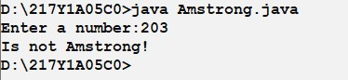

**Aim:** write a java program to find roots of Quadratic equation.

**File name:** Quadratic.java

**Program:**

**//HELLO**

**import java.lang.*;**

**import java.util.*;**

**class Quadratic{**

**public static void main(String args[]){**

**int a,b,c,delta;**

**Scanner s=new Scanner(System.in);**

**System.out.print("Enter a,b,c values:");**

**a = s.nextInt();**

**b = s.nextInt();**

**c = s.nextInt();**

**delta = b*b-4*a*c;**

**if(delta>0){**

**double r1 = (-b + Math.sqrt(delta))/2*a;**

**double r2 = (-b - Math.sqrt(delta))/2*a;**

**System.out.print("Roots are:"+r1+","+r2);**

**}**

**else if (delta == 0){**

**double r = (-b/2*a);**

**System.out.print("Roots are:"+r+","+r);**

**}**

**else{**

**System.out.print("Roots are imaginary");**

**}**

**}**

**}**

**Output:**

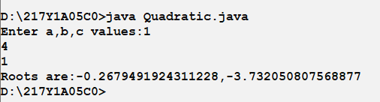

**Aim:** write a java program to calculate current bill.

**File name:** CurrentBill.java

**Program:**

**import java.lang.*;**

**import java.util.*;**

**class CurrentBill{**

**public static void main(String args[]){**

**int units;**

**double amt=0.0,rate;**

**Scanner s=new Scanner(System.in);**

**System.out.print("Enter no.of units:");**

**units=s.nextInt();**

**if(units<=100){**

**amt=units*1.25;**

**}**

**else if(100<units && units<=200){**

**amt=100*1.25+(units-100)*2;**

**}**

**else if(200<units && units<=300){**

**amt=100*1.25 + 100*2 + (units-200)*2.75;**

**}**

**else{**

**amt=100*1.25 + 100*2 + 100*2.75 + (units-300)*3;**

**}**

**System.out.print("Amount = "+amt);**

**}**

**}**

**Output:**

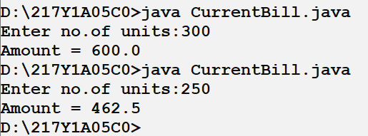

**Aim:** write a java program to find whether a string is palindrome or not.

**File name:** Palindrome.java

**Program:**

**import java.util.*;**

**public class Palindrome{**

**public static void main(String[] args) {**

**Scanner sc = new Scanner(System.in);**

**System.out.println("Enter a String: ");**

**String str = sc.nextLine();**

**int n = str.length();**

**for(int i = 0;i < n;i++){**

**if(str.charAt(i) != str.charAt(n - i - 1)){**

**System.out.println("Not a Palindrome.");**

**sc.close();**

**return;**

**}**

**}**

**System.out.println("Palindrome.");**

**sc.close();**

**}**

**}**

**Output:**

